 | JSPM’s  RAJARSHI SHAHU COLLEGE OF ENGINEERING  TATHAWADE, PUNE-33  (An Autonomous Institute Affiliated to SavitribaiPhule Pune University,Pune) | 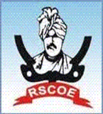

Department of Information Technology
Innovation by Faculties in Teaching Learning

Name of the Course: Java Programming
Name of the Faculty: Prof. Deepti Gupta
Name of the Innovative Method used: Project Based Learning
Name of the topic: Website Creating using Java and App Creation using Java.
Statement of Clear Goal:
Project-Based Learning (PBL) is an innovative instructional method that centers learning around the completion of real-world projects. Unlike traditional rote learning, PBL engages students in hands-on, collaborative problem-solving, requiring them to apply knowledge and skills in meaningful contexts. This approach prepares learners for the complexities of modern life and work.
Objectives of Implementing PBL
- Foster critical thinking, collaboration, and creativity
- Connect academic content with real-life applications
- Enhance student engagement and motivation
- Improve communication and presentation skills
- Encourage self-directed and lifelong learning
Methodology
The PBL approach follows these key phases:

Project Design

Selection of real-world problems or challenges

Integration of interdisciplinary content
- Definition of learning outcomes and assessment criteria

b) Team Formation
- Students work in groups to encourage peer learning and shared responsibility
c) Inquiry and Research

- Learners conduct research, collect data, and explore possible solutions
- Teachers act as facilitators rather than direct instructors

d) Solution Development
- Students brainstorm and develop tangible products or solutions
- Iterative prototyping and feedback sessions are included

e) Presentation and Reflection
- Final projects are presented to an audience (peers, teachers, community members
- Reflection on learning outcomes, challenges, and collaboration is conducted
Implementation
- Project Title: Women Safety: Real-Time SOS & Voice Alert System
Class : TY-A
Technology Used:

Frontend: Android (XML-based UI in Android Studio)

Backend: Java (core application logic)

Database: SQLite (storing emergency contacts & custom messages)

APIs/Services:

Android SMS Manager – for sending SOS and voice alert messages.

Google Location Services (GPS) – for live location tracking.
Duration: 6 months
Team Member: Nachiket Bhadane (RBT23IT029)
Anuj Sawant(RBT23IT027)
Mangesh Jagtap(RBT23IT044)
Outcome:

This women safety application combines real-time SOS alerts, location tracking, and innovative buzzer/voice alert features to ensure maximum safety. With its Java-based backend in Android Studio, the app is lightweight, reliable, and user-friendly, offering a practical solution for emergencies.
Effective Presentation (Screenshot):

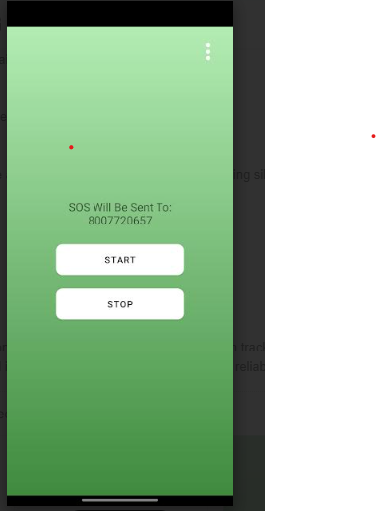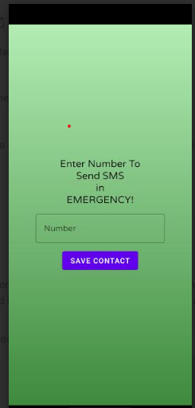

- Project Title: QuizKar
Class : TY-A
Technology Used:Built using Java Servlets, JSP, PostgreSQL, and Maven with a modular MVC architecture.
Duration: 6 months
Team Member: Omkar Kshirsagar (RBT23IT019)
Anjali Sawant(RBT23IT015)
Vivek Misar(RBT23IT064)
Outcome:
QuizKar stands out as a robust educational platform that blends structured learning with competitive gamification, making study progress measurable, engaging, and future-ready.

Effective Presentation (Screenshot):
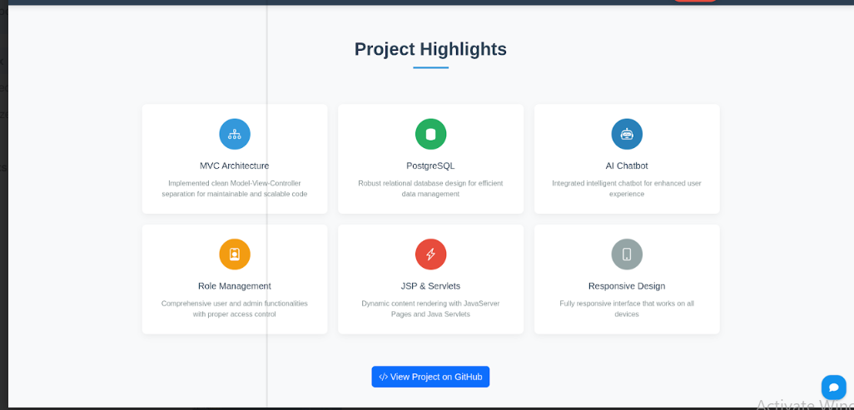
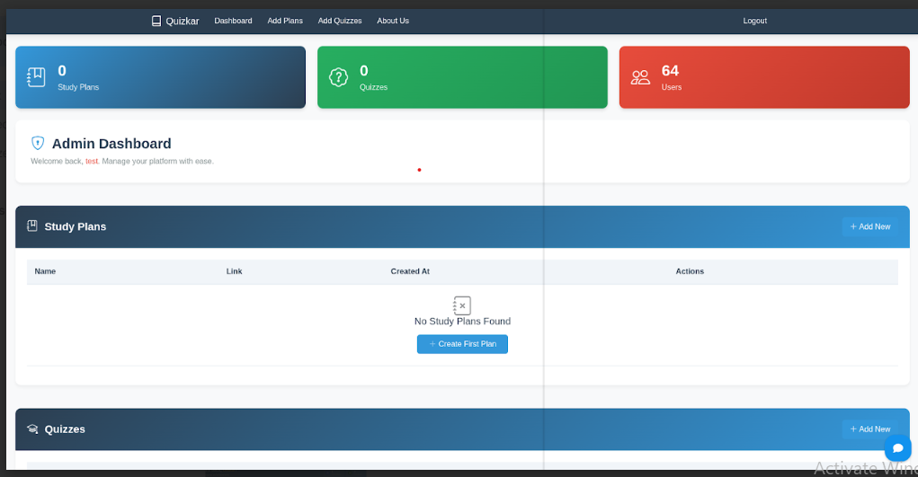

B. Availability of work related to Innovation by Faculty in Teaching and Learning is on online .

https://www.jspmrscoe.edu.in/information-technology/innovation-practices

- Availability of work for peer review and critique are available online
Work is available for peer review and critique on github.

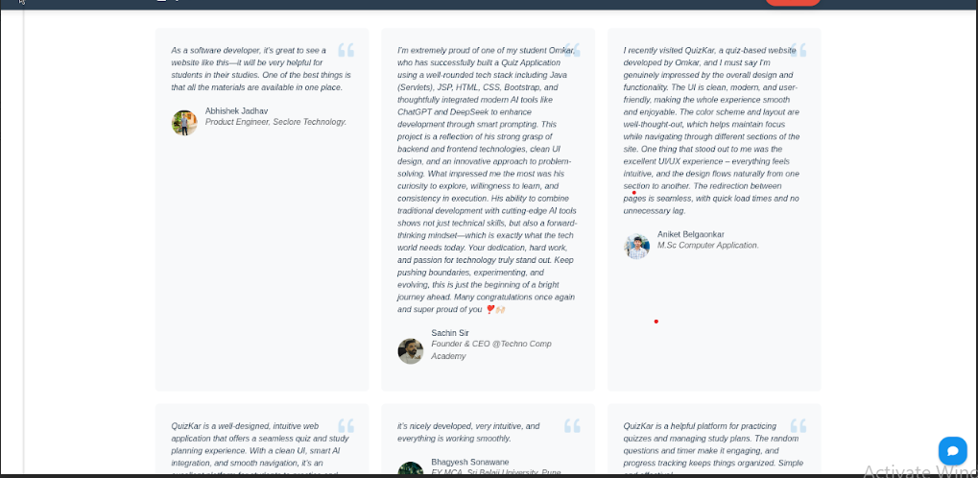

D: Reproducibility and Reusability by other scholars for further development

- Increased student engagement and ownership of learning
- Improved problem-solving and collaborative skills
- Higher retention of academic content
- Real-world skill development: time management, decision-making, and adaptability

Sr.  No. | Innovation Used | Content prepared by | Purpose of  Reproducibility and Reusability
1. | Project Based Learning | Deepti Gupta | To increased student engagement and ownership of learning.  To improved problem-solving and collaborative skills.  To understand real-world problems.

Course Co-ordinator Module Co-ordinator HOD
Deepti Gupta Dr. Dipmala Salunke Dr. Nihar M. Ranjan

